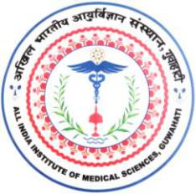
अखिल भारतीय आयुर्विज्ञानसंस्थान(एम्स), गुवाहाटी

All India Institute of Medical Sciences, Guwahati

स्वास्थ्य और पररवार कल्याण मंत्रालय,भारत सरकार केतत्वावधान मेंएकवैधाननकननकाय

(A statutory body under the aegis of Ministry of Health and Family Welfare, GoI)

_________________________________________________________________________________________________

LEAVE AVAILING/JOINING REPORT

Name :

Designation

:

Department

Nature of leave

:

:

Duration

:

Commencement of Leave

:

Date:

(Signature of the Applicant)

Executive Director/ Dean/ HoD

Joined back on duty

:

Date:

(Signature of the Applicant)

Executive Director/ Dean/ HoD

